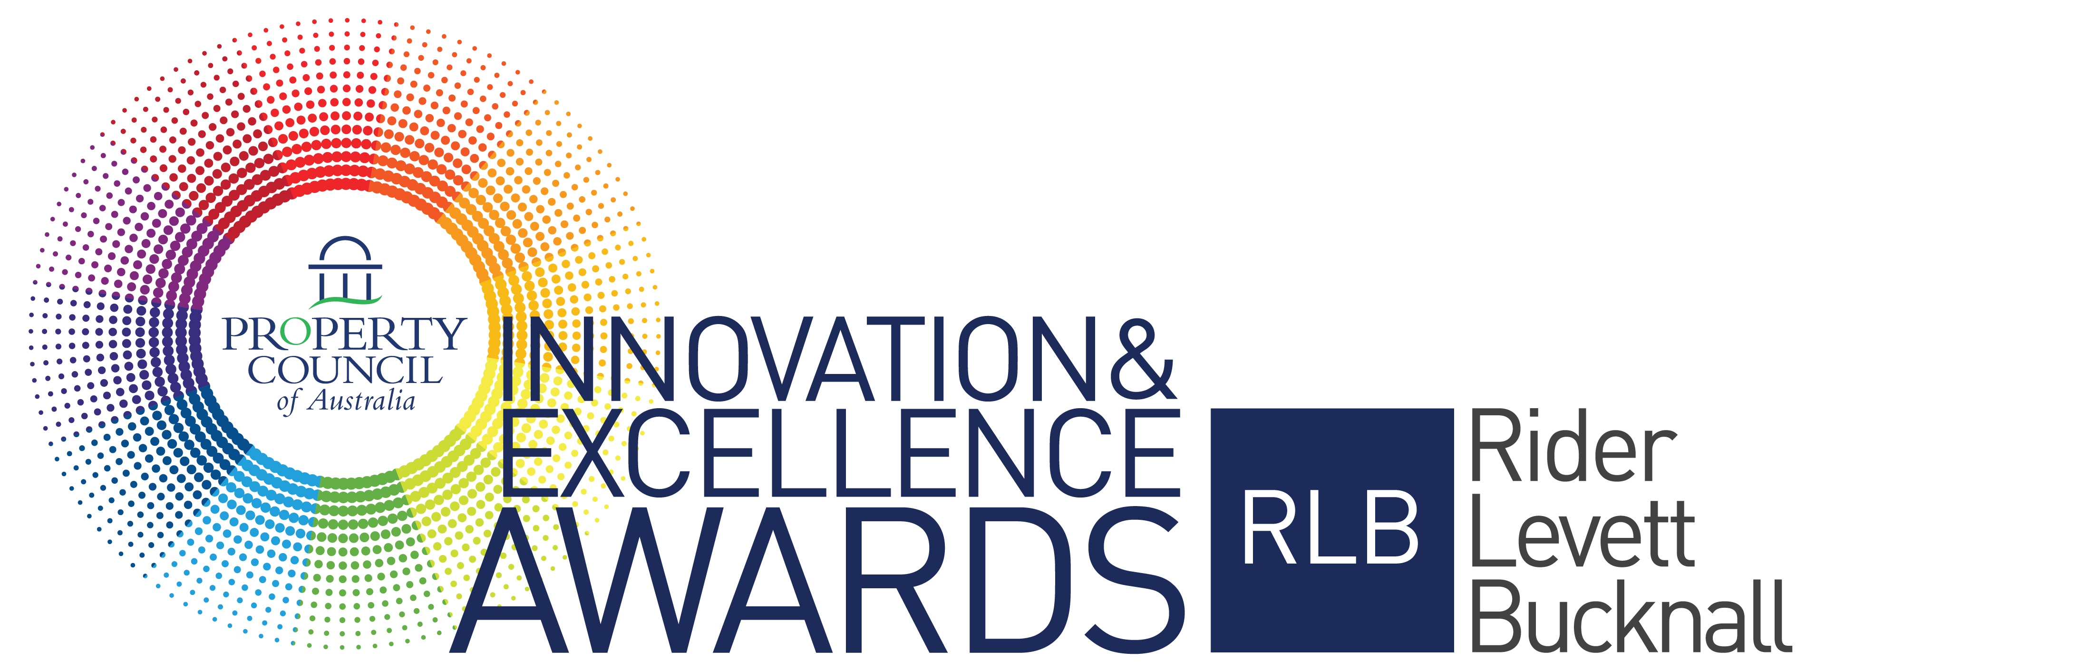

2020 Award Criteria & Questions

Award for Best Residential Development

Sponsored by

Award Criteria

This award aims to recognise and publicly reward the efficient use of capital in a new or refurbished
residential development.

Eligible entrants will be developments or refurbishments that have been completed in the previous five
years, have been operating for at least one year as at 31 December 2019 and have not previously won the Award.

Also, where the development is multi staged the entrant may nominate a completed stage and will be awarded on the basis of the completed stage only. The entrant may also enter further stages as they are completed in future years but will only be recognised for those nominated stages not previous ones.

The award is open to members of the Property Council of Australia only. (Note: Nominated companies must be a Property Council of Australia member in the state where the project is located). Innovation in your responses should be clearly expressed.

All finalist projects for the National Awards will automatically be entered into their State Development of the Year. This award is presented in each state at a cocktail party prior to the National Awards Gala Dinner.

The State Development of the Year is determined by the National Awards judging panel and is awarded to the highest scored development in that state. An invitation will be issued to all finalists early in 2020 with details of their State Development of the Year event.

Nomination Form Questions

NOMINATOR / CONTACT PERSON
Name
Position
Company
Mailing Address
Contact Number (Day)
Email
Mobile

DEVELOPMENT DETAILS
Name of Development
Address of development
Development type
Completion of development/refurbishment
Development size (NLA sqm)

OWNER DETAILS
Name
Position
Company
Mailing Address
Email
Phone Number (Day)

PROJECT TEAM
Developer
Architect
Planner
Quantity Surveyor
Builder
Consultants
Financier
Other

AWARD CEREMONY DETAILS
The winners will be presented at the Innovation & Excellence Awards Gala Dinner in Sydney on Friday, 15 May 2020. Should you be successful in winning this award, who will be receiving the award at the event?
Name
Position
Company
Mobile
Email

PROJECT SYNOPSIS
To assist judges in assessing your entry against the judging criteria, please provide a project synopsis of no more than 300 words.

MARKETING SYNOPSIS
To assist the organiser in promoting your entry within marketing material, please provide a summary about your entry of no more than 50 words.

DEVELOPMENT DETAILS UPON COMPLETION
Total Project Costs - $
Development Margin (%)
Development Profit - $
Project IRR (%)
Date of Completion
Current Valuation as supported by independent valuation - $
Total NLA Leased (%)

ATTACHMENTS
Please upload a maximum of 6 images (minimum of 4 images is mandatory). Images are to be in a jpg format and high resolution (300dpi) and a maximum file size of 5MB each.

Judging Criteria

ECONOMIC AND FINANCIAL FACTORS – 35% WEIGHTING (Limit 800 words)

Detail how the development demonstrates the ability to perform in the top quartile of investment returns.

PROJECT VISION AND INNOVATION – 15% WEIGHTING (Limit 800 words)

Describe how the development displays innovation in the project concept and in overcoming site or development complexities. This should be described as a point of difference.

CORPORATE SOCIAL RESPONSIBLITY – 15% WEIGHTING (Limit 800 words)

Describe the tangible economic, environmental and social dividends.

QUALITY OF DESIGN AND FINISH – 15% WEIGHTING (Limit 800 words)

Detail and provide examples on how the development exhibits a high quality of architectural design; is compatible with surrounding land uses and contributes to the success of the development project (e.g. site constraints, unique design solutions, and project cost constraints). Include supporting pictures.

RESIDENT SATISFACTION – 10% WEIGHTING (Limit 800 words)

Describe, using testimonials from a variety of stakeholders, the extent to which the development has a proven high satisfaction level of all users.

INDUSTRY PERCEPTION – 10% WEIGHTING (Limit 800 words)

Describe, using testimonials from a variety of stakeholders, the extent to which the development is considered a success by the property marketplace.

Conditions of Entry

- Entry in the Property Council of Australia/Rider Levett Bucknall Innovation & Excellence Awards costs $1,260 (including GST) per nomination.
- Nominated companies must be a Property Council of Australia member in the state where the project is located.
- We welcome both self-nomination and third party nominations.
- Before you submit your nomination, ensure you have permission from the owner, your client or your contractor to do so.
- All entries must be submitted via the online Nomination form.
- Entries must stick to the word limit on the online nomination form. Nominees are reminded that judges will not consider formatting or presentation of entries.
- Nominees must include 4-6 images to support their submission. Other material relevant to support the application may also be uploaded as an Appendix.
- All nominees should be prepared to attend a site inspection with a judge, should it be deemed necessary.
- All nominations and contents will remain the property of the Property Council of Australia.
- Please note entries are exclusive to the Property Council of Australia Innovation & Excellence Awards and no details private or professional will be distributed to outside contacts.
- The judge’s decision is final and no communication will be entered into concerning the final decision.
- The Property Council of Australia reserves the right to publish the results and winner details.
- The finalists should be available to attend two events - The Property Council of Australia/Rider Levett Bucknall Innovation & Excellence Awards Gala Dinner to be held in Sydney at the ICC on Friday, 15 May 2020 and the State Development of the Year Event held prior to the awards in each state (details to be provided.)
- All entries must be received and paid by 5:00 pm (AEST) on Friday 15 November 2019.

Sponsored by

