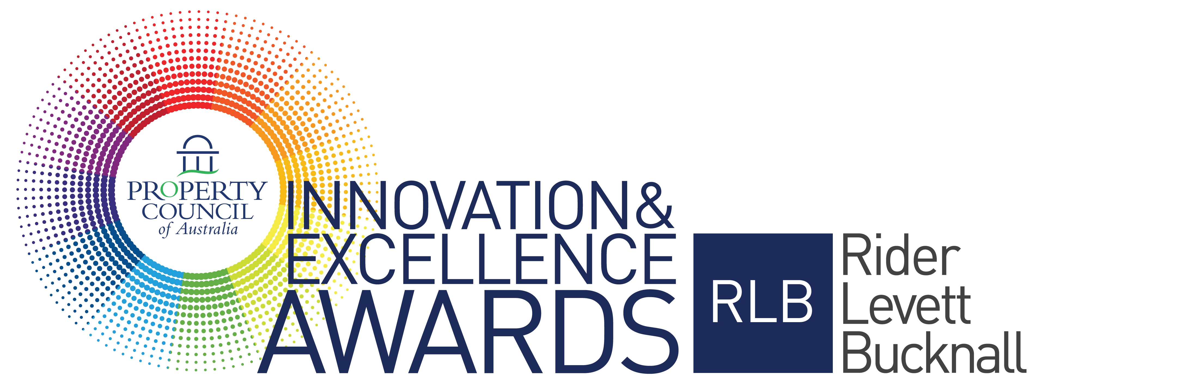

2020 Award Criteria & Questions

Award for Government
Leadership

Sponsored by

Award Criteria

This award recognises significant innovation and excellence of a local, state or federal government
department or authority in its dealings with the property investment and development industries.

Eligible entrants will be developments or refurbishments that have been completed in the previous five years, have been operating for at least one year as at 31 December 2019 and have not previously
won the Award.

The award is open to members of the Property Council of Australia only. (Note: Nominated companies must be a Property Council of Australia member in the state where the project is located). Innovation in your responses should be clearly expressed.

All finalist projects for the National Awards will automatically be entered into their State Development of the Year. This award is presented in each state at a cocktail party prior to the National Awards Gala Dinner.

The State Development of the Year is determined by the National Awards judging panel and is awarded to the highest scored development in that state. An invitation will be issued to all finalists early in 2020 with details of their State Development of the Year event.

Nomination Form Questions (final entries must be submitted using the online nomination form)

NOMINATOR / CONTACT PERSON
Name
Position
Company
Mailing Address
Contact Number (Day)
Email
Mobile

DEVELOPMENT DETAILS
Name of Development
Address of development
Development type
Completion of development/refurbishment
Development size (NLA sqm)

PROJECT TEAM
Developer
Architect
Planner
Quantity Surveyor
Builder
Consultants
Financier
Other

AWARD CEREMONY DETAILS
The winners will be presented at the Innovation & Excellence Awards Gala Dinner in Sydney on Friday, 15 May 2020. Should you be successful in winning this award, who will be receiving the award at the event?
Name
Position
Company
Mobile
Email

PROJECT SYNOPSIS
To assist judges in assessing your entry against the judging criteria, please provide a project synopsis of no more than 300 words.

MARKETING SYNOPSIS
To assist the organiser in promoting your entry within marketing material, please provide a summary about your entry of no more than 50 words.

ATTACHMENTS
Please upload a maximum of 6 images (minimum of 4 images is mandatory). Images are to be in a jpg format and high resolution (300dpi) and a maximum file size of 5MB each.

Judging Criteria

CUSTOMER SERVICE – 25% WEIGHTING (Limit 800 words)

Explain how the government demonstrates innovation and excellence in delivery of customer service to
all stakeholders.

STRATEGIC PLANNING – 25% WEIGHTING (Limit 800 words)

Development and implementation of a best practice strategic planning framework that:

- Draws on solid research and focuses on facilitation, short term actions and longer term urban management objectives;
- Demonstrates innovation in economic development strategies, including infrastructure planning, within broader ESD principles;
- Engages the community and business in the strategic planning process;
- Provides for the regular and timely reviews of statutory plans to ensure they meet and balance evolving community values and dynamic industry needs;
- Provides accountable policy implementation through clear, concise planning instruments that can be readily understood and applied by both industry and community.

DEVELOPMENT ASSESSMENT – 25% WEIGHTING (Limit 800 words)

Deliver a development assessment process that demonstrates the advancement of best practice principles:

• The independent application of objective rules and tests linked to stated policy intentions;
• Provides for timely and transparent decision making;
• Applies an assessment track appropriate to the proposal;
• Demonstrates efficiency of process in dealing with assessment from other agencies or authorities.

PROJECT MANAGEMENT – 25% WEIGHTING (Limit 800 words)

Explain, using examples, how the nominated Government contributed to the successful delivery of a major project that met the needs of the developer, investors and community.

Conditions of Entry

- Entry in the Property Council of Australia/Rider Levett Bucknall Innovation & Excellence Awards costs $1,260 (including GST) per nomination.
- Nominated companies must be a Property Council of Australia member in the state where the project is located.
- We welcome both self-nomination and third party nominations.
- Before you submit your nomination, ensure you have permission from the owner, your client or your contractor to do so.
- All entries must be submitted via the online Nomination form.
- Entries must stick to the word limit on the online nomination form. Nominees are reminded that judges will not consider formatting or presentation of entries.
- Nominees must include 4-6 images to support their submission. Other material relevant to support the application may also be uploaded as an Appendix.
- All nominees should be prepared to attend a site inspection with a judge, should it be deemed necessary.
- All nominations and contents will remain the property of the Property Council of Australia.
- Please note entries are exclusive to the Property Council of Australia Innovation & Excellence Awards and no details private or professional will be distributed to outside contacts.
- The judge’s decision is final and no communication will be entered into concerning the final decision.
- The Property Council of Australia reserves the right to publish the results and winner details.
- The finalists should be available to attend two events - The Property Council of Australia/Rider Levett Bucknall Innovation & Excellence Awards Gala Dinner to be held in Sydney at the ICC on Friday, 15 May 2020 and the State Development of the Year Event held prior to the awards in each state (details to be provided.)
- All entries must be received and paid by 5:00 pm (AEST) on Friday 15 November 2019.

